Oxford Owl User Guide
- Visit Oxford Owl and select Join us at the top right corner.

- Select Parent in the About You section.
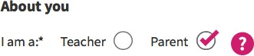

- Fill out your contact information and login credentials.
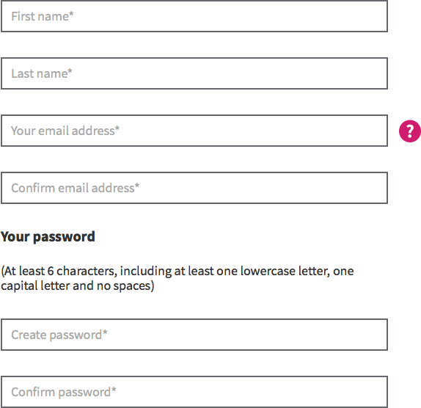

- Click Step 2 once all the required fields have been completed. In step 2, leave the child age blank and accept the Terms and Conditions of use.
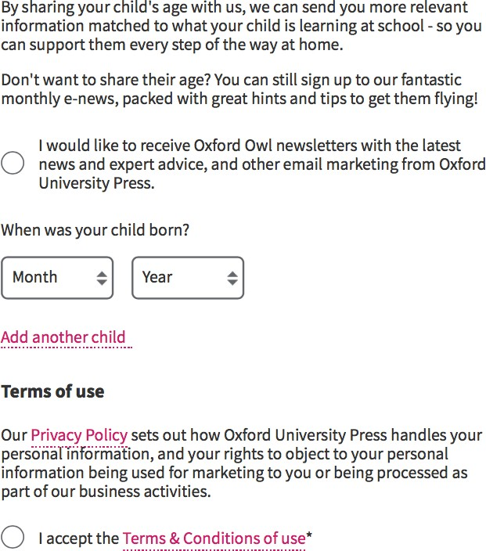

- A confirmation email will be sent to your account. Click on the link in the email to confirm your registration.
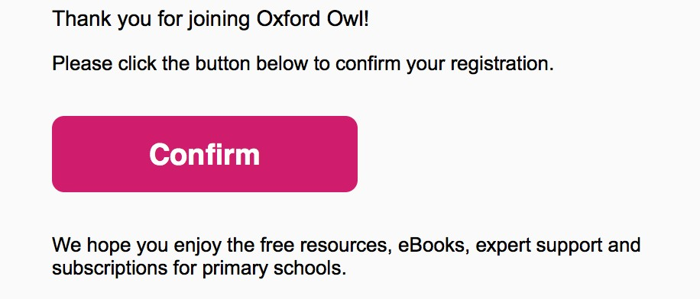

- To access the e-Book library, login to your account and select Enter Site under the Oxford Owl for Home option or visit the Oxford Owl eBook Library page here.
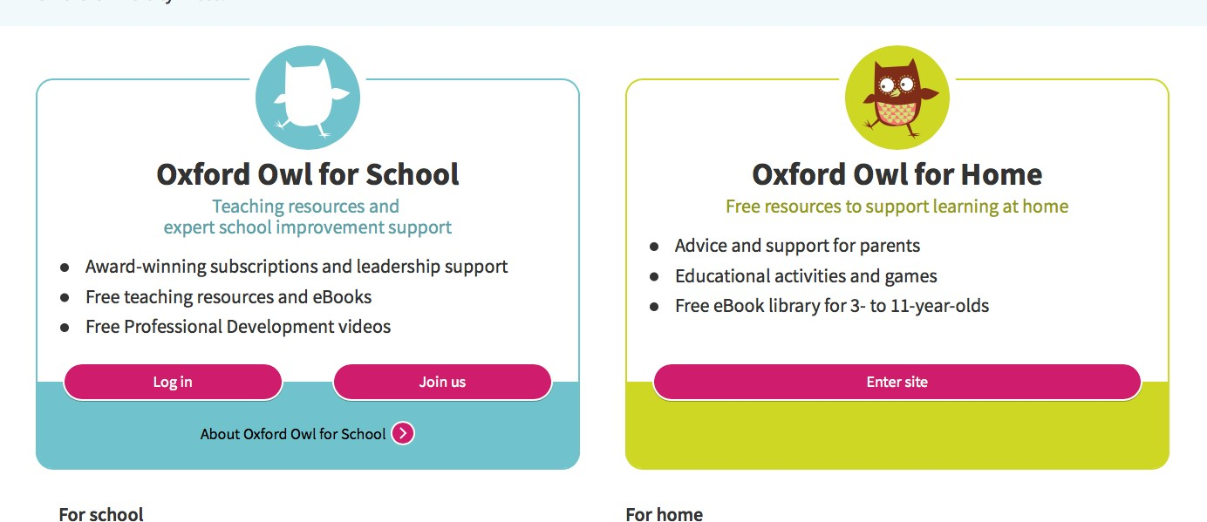

- The Oxford Owl eBook Library page may be browsed by age, level, book type, and series.
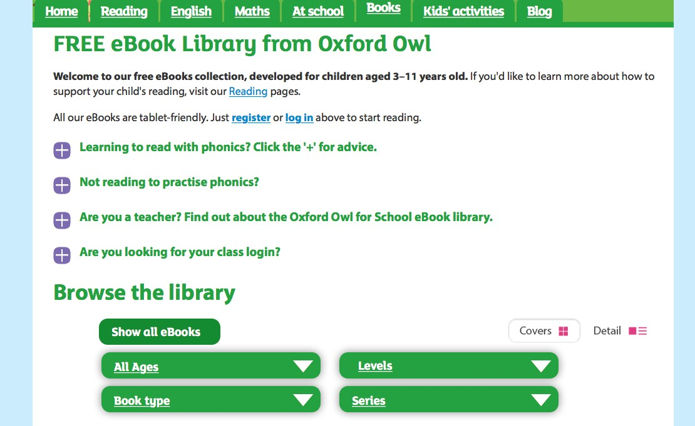

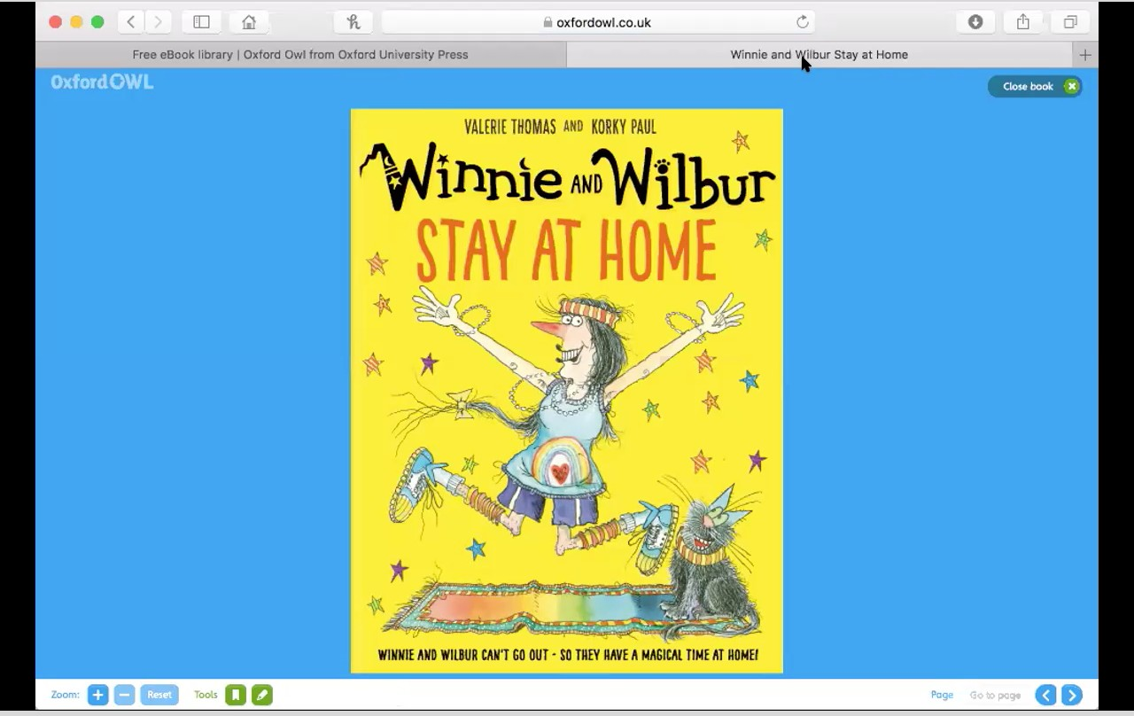
- Enable screen-sharing to display the eBook library.

