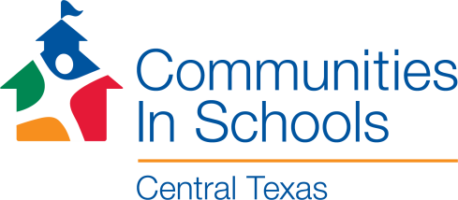 Talking Points for Parents

Key messages for phone, text, and emails with parents about CIS:
- Communities In Schools is a safe and supportive program for students.
- We believe that every student deserves the opportunity to succeed in school.
- We are a nonprofit organization partnering with your school. We have an office on campus. (insert information about how to contact you – phone, email, room #)
- We help students learn, stay in school, and prepare for a successful future.
- Our mission is to empower students to achieve, both in school, and in the future.
- Every child is unique and Communities In Schools offers a variety of programs to help support each individual student. Our services include:
  - Individual and small group time to provide support and encouragement
  - Assistance for students and their families with basic needs
  - Academic support, career exploration, and fun learning activities
  - (insert specific information about your programming as needed)
- Our services are free, voluntary, and confidential.
- Parents, teachers, school staff, and students themselves may request Communities In Schools services.
- Students involved with Communities In Schools report that they feel better about school, are happier with themselves, and have learned skills that help them resolve problems—both in school and in life.
- Communities In Schools supports students so they can improve their grades, attendance, and/or behavior.
- You can learn more about Communities In Schools on our website at https://ciscentraltexas.org/about-us/

