Email Signature Instructions

Step 1. Save a copy of this document to use and reference.
Step 2. Select the graphic you would like to use in your signature from the 5 options below.

-- Option #1.

-- Option #2.

-- Option #3.

-- Option #4.

-- Option #5.

AmeriCorps Members
- Please choose option #3, #4 or #5
- Please use AmeriCorps in your title -- AmeriCorps member or AmeriCorps EAO member, AmeriCorps VISTA

Step 3. Find the signature option on page 4 with the graphic you selected. Type in your name, title, campus name or program name, and street address, phone and email address.
- If you work at Central, simply include the organization name rather than Campus name/address

Step 4. Copy the entire signature from page 5 which includes:
- Your contact info (name, title, Campus name if campus-based, phone & email)
- The image you selected

Note: The images do not show up on phone signatures and web-based email signatures, so copy and paste your name and contact info without the graphic when updating your phone and web-based email signatures.

Step 5. In Outlook, in the top left, click FILE – then OPTIONS
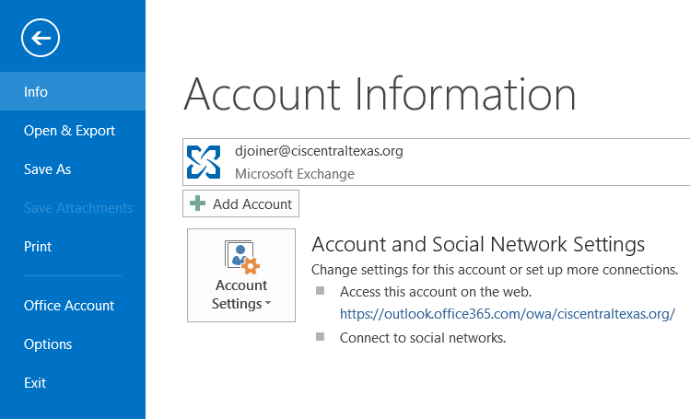

Step 6. Next, click MAIL then SIGNATURES
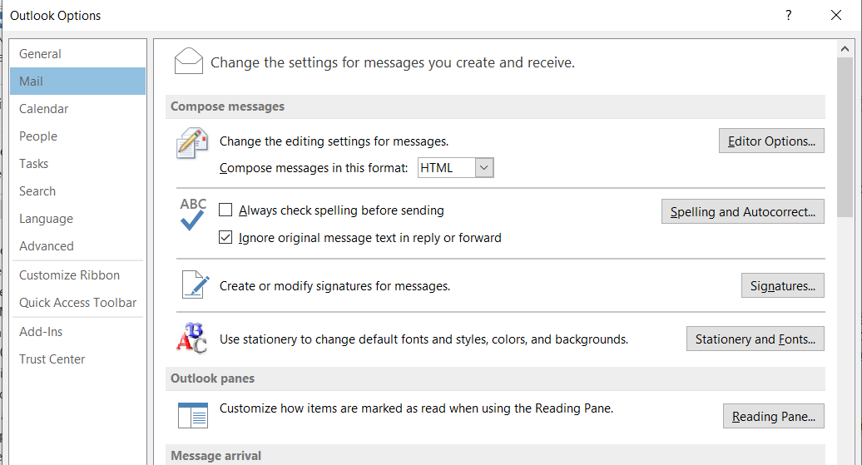

Step 7. Paste the new signature into the box and click OK twice to save.
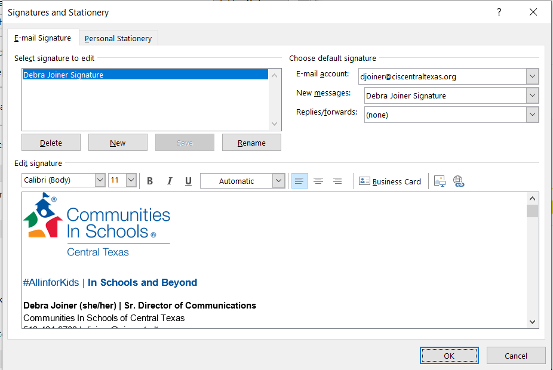

FirsN LastN | Your Title
Street Address, City, State Zip Code
Phone Number, Email Address

FirsN LastN | Your Title
Street Address, City, State Zip Code
Phone Number, Email Address

FirsN LastN | Your Title
Street Address, City, State Zip Code
Phone Number, Email Address

FirsN LastN | Your Title
Street Address, City, State Zip Code
Phone Number, Email Address

FirsN LastN | Your Title
Street Address, City, State Zip Code
Phone Number, Email Address

