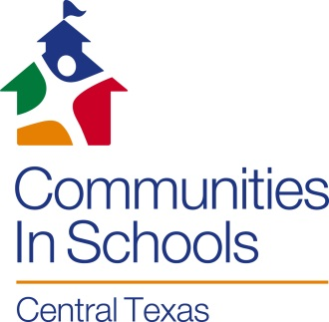
Parent / Guardian Release

I give permission for my child ___________________________________ to participate in a photo shoot sponsored by Communities In Schools of Central Texas (CIS) that will involve photographs of me and/or my child. This may include use of photos, video, recordings, and/or other media featuring me/and my child that may be made available to a variety of public entities via the internet, broadcast, print or other forms of media.

I understand that my permission is being given so that:

- Communities In Schools may collect and use photographs or video picture(s) of me and/or my child for promotional purposes
- My child’s voice and image may be used on the internet, in television broadcasts, radio broadcasts, newspaper articles, and on social media on behalf of CIS

I release Communities In Schools of Central Texas and its employees and representatives from any liability that may occur due to my child’s participation in CIS activities that involve the media.

My child and I understand that participation in the CIS program and any engagement with the media is voluntary.

Parent/Guardian Name (please print):__________________________________________

Child’s Name (please print): __________________________________________________

Parent/Guardian Signature: Date: _____________ (Signature must be in ink)

