Zoom Meeting Set-Up
To schedule a Zoom meeting, click on Schedule Meeting on the menu, top right corner of the webpage:
Once you click on Schedule a Meeting, you will be directed to your Schedule a Meeting screen. Enter all relevant information for your meeting. Click Save.
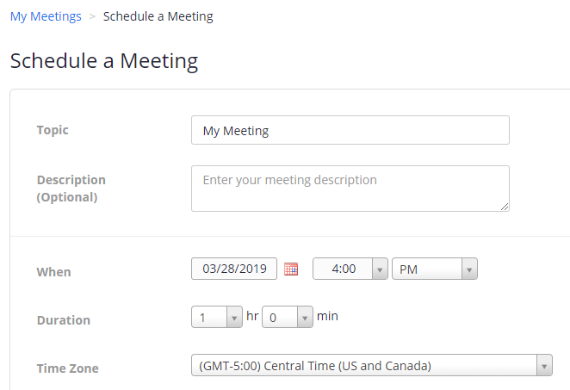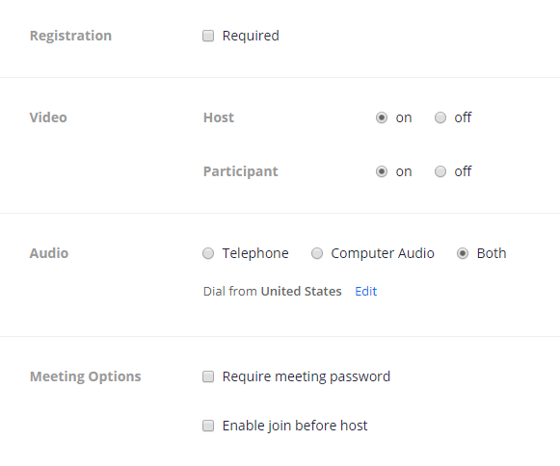
After you click save you will be provided with a meeting summary, meeting ID, URL.
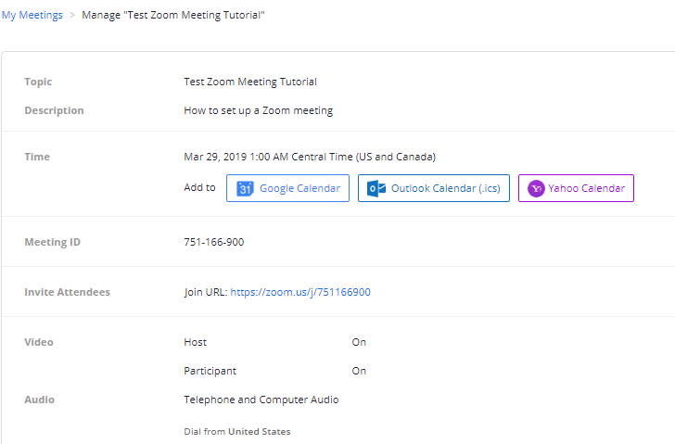
In the middle section of your meeting summary you will see Invite Attendees. You can copy the URL or the invitation to send via email or calendar invite to your attendees. The invitation will give you the call-in phone number, link to the meeting and the meeting ID. Click on Copy Meeting Invitation.
